**EXPERIMENT 2**

**AIM: Working with Docker (Basic Commands)**

**Steps to Complete:**

1. Search a Redis image on DockerHub

**Command-docker search redis**

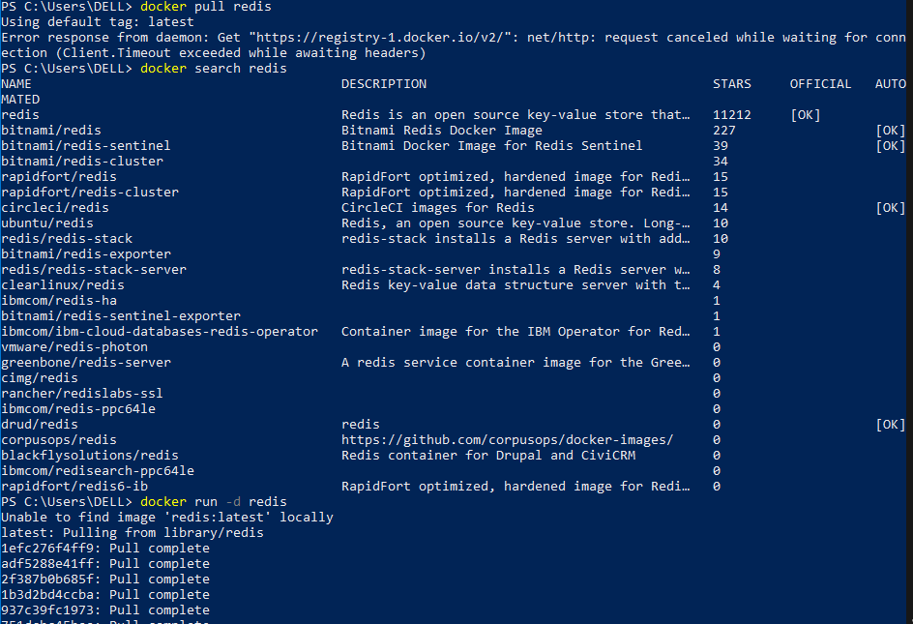

1. Run Docker Container of Redis Image in background

**Command- docker run -d redis**

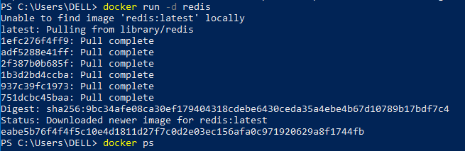

1. Run Docker PS and Docker PS –a

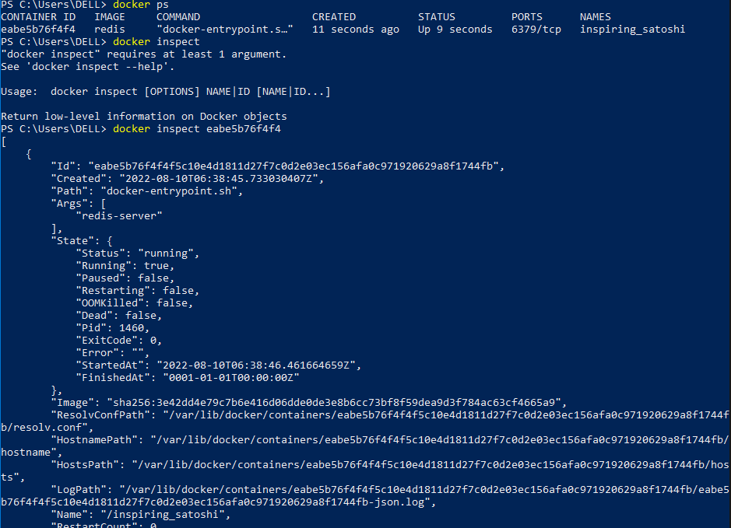

1. Run Docker Container and take its console

Command- run -it redis/bin/bash

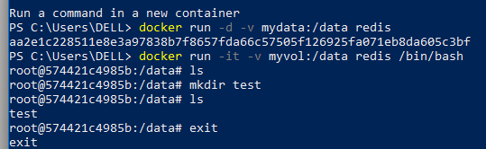

1. Create a Docker Volume and connect

